REGISTRATION FORM
Name of Child |  |  |  |  | Date of Birth
Child known as |  |  |  | Gender (male or female)
Name of parent(s) with whom the child lives
Parent 1 Name
Mobile no
Email address
Does this parent have parental responsibility? Yes/No Evidence Provided Yes/No (delete)
Parent 2 Name
Mobile no
Email address
Does this parent have parental responsibility? Yes/No Evidence Provided Yes/No (delete)
Address
Name of parent with whom the child does not live
Does this parent have parental responsibility? Yes/No Evidence Provided Yes/No (delete)
Address
Telephone |  |  |  | Mobile
Does this parent have legal access to the child? Yes/No (delete)
Emergency Contacts and Authorised Adults for Collection other than parent(s)
(Must be over 16 years of age)
Name |  | Relationship to child
Telephone |  | Mobile
Name |  | Relationship to child
Telephone |  | Mobile
Name |  | Relationship to child
Telephone |  | Mobile
Family GP, Address and Telephone Number
_______________________________________________________________
_______________________________________________________________
Personal details of child
Does your child suffer from any known medical conditions or allergies, or have any special dietary needs or preferences? Yes/No (please circle)

Vegan Vegetarian Halal Pescetarian (fish but no meat)

Any food you do not wish your child to eat? (for example, no chicken, no pork, no beef, no milk, no eggs, no cheese)__________________________________________________
The reason for this (please circle): religion lifestyle allergy intolerance

Medical conditions ___________________________________________

Allergies/intolerances _________________________________________

Has a risk assessment, if required, been completed? Yes/No (delete)
Has a health care plan and agreement to administer medicine, if required, been completed? Yes/No (delete)
How would you describe your child's ethnicity or cultural background?

What is the main religion in your family?

Are there any festivals or special occasions celebrated in your culture that your child will be taking part in and that you would like to see acknowledged and celebrated while he/she is in our setting? Please tell us how you celebrate this

What language(s) is/ are spoken at home

What language does your child respond to/speak? ______________________________

Will this be your child's first experience of being in an English-speaking environment? Yes/No (delete)

If so, discuss and agree with the key person how you will support your child when settling-in:

Does your child have any additional needs or disabilities? Yes/No (delete)
Details:

What other information is it important for us to know about your child? For example, what they like, or what fears they may have, any special words they use, or what comforter they may need and when (additional to ‘all about me’ sheet).

Names of professionals involved with child
Name 1 |  | Role
Agency |  | Telephone
Name 2 |  | Role
Agency |  | Telephone
Name 3 |  | Role
Agency |  | Telephone
Do you have a health visitor? |  | Yes/No (delete)
Name |  | Based at
Telephone
Does your family have a social care worker for any reason? Yes/No (delete)
Name: |  | Based at:
Tel:
What is the reason for the involvement of the social care department with your family?

NB If the child has a child protection plan, make a note here, but do not include details. Ensure these are obtained from the social care worker named above and keep these securely in the child's file.

Does your child have any identifying features such as birthmarks, strawberry marks, moles etc.. This is to ensure that when we complete accident forms we do not get confused between a bruise/graze and a distinctive feature on a child.
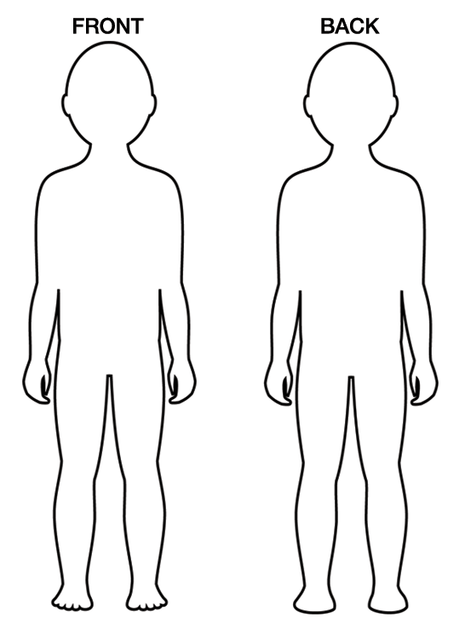

Daily outings
Your child will be taken out of the setting as part of the daily activities. The venues used are detailed here:
Our Lady of Lourdes Primary School, Our Lady of Lourdes Parish Church,
Kingswood Library, Kingswood Park, Local Shops ie. Bakery
For any major outings, we will inform you and ask for your specific consent.
Sun Protection Permission

- I have read and understood the Pre-School Sun Policy.
- I give permission for Pre-School to apply sunscreen to my
    - child during hot weather.
- I have supplied Pre-School with sun cream
- I am happy for preschool to use their own if needed.
Parent/Carers name___________________________ Signed:_______________________

- I/we have been provided with details of the setting’s policies and procedures, including the Information Sharing procedures, GDPR requirements and understand that there may be circumstances where information is shared with other professionals or agencies without my consent.
- I/we also understand, that if required, my/our child will be taken by staff to the nearest Accident and Emergency unit to be examined, treated or admitted as necessary, on the understanding that I/we have been informed and are on our way to the hospital. I give my permission for my child to be given emergency treatment as necessary.
- I/we understand that my child may visit the local surrounding area in small groups as described in ‘daily outings’ above.

Please delete any parts of the above statements which you do not give consent to.

Authorisation:

Parent 1 |  | Parent 2
Key person |  | Manager
Date |  | Date

Security Password

To ensure your child’s safety and protection please provide a password on the slip below to be used in a situation when you are unable to collect your child. The password should be given to the person whom you wish to collect your child on your behalf in an unplanned situation.
If you know in advance that somebody else is collecting your child please inform us also any change in your circumstances may require your password to be changed, in this instance please inform the pre-school and change your password immediately.

SECURITY PASSWORD_________________________________

Text service

We will be able to send you text messages for personal reminders, social events, closures due to bad weather, special events in Pre-School and any other important information when we need to inform you urgently alone with a Facebook parent group post or email.

The information will be held by the administration team in Our Lady of Lourdes Pre-School and only they will have access to send the text messages from pre-school. Upon your child leaving the Pre-School your data will be deleted from the text system. If you would like more information on the service please ask,
We can only have one mobile number per child to send these messages to.
Leaving your number here you agree to Our Lady of Lourdes Pre- School holding your contact details, us sending you messages, confirm we have the correct number as a first contact (1 number only).

Parent/Carers name - ______________________Mobile number - ______________________

Photography Consent

Photography and Observation Records
I understand that in line with Ofsted requirements, my child will be observed and monitored as part of their development planning. This will include the taking of photos and occasional use of video. All records will be kept strictly confidential. I give permission for my child to be observed, photographed and/or videoed as part of their development monitoring. I also give permission for photos of my child to be used in pre-school displays, newsletters, the Pre-School website, staff coursework and other activities related to the running of the Pre-School.
Photography and Video Recording at Pre-School Special Events
I understand that it is Our Lady of Lourdes Pre-School policy to allow parents to record the special milestones in their child’s development. I am aware that the Pre-School will give permission to parents and carers to take photos and videos of their children, which are implicitly for their own personal use, at pre-arranged pre-school special events. I give permission for my child to attend these events, with the knowledge that other parents might be taking photos/videos of their child. I agree to ensure that all images I take at these special occasions will be of my child only and will be for my personal use and will be kept securely and used appropriately. Any images I share on social media I will ensure have no other child either in the forefront or background of the pictures I take, other than my own.

Parent/Carers name___________________________ Signed:_______________________

